Title of your Paper in Times New Roman 12 bolt

Dr Henry Klein¹, Max Mustermann¹, Dr Simone Example²
Institute for Thermal Energy Systems¹
Example Street17, 8010 Graz, Austria
Phone: +43 3112 / 34 5 67
Institute for Renewable Heating²
Street 19, 8010 Graz, Austria
E-Mail: sunshine4u@soon.com

Summary
The summary should not exceed 10 lines, and should include key-words. Text Times New Roman 11

Introduction
This is both a guideline and a template for preparing your full paper. To format your manuscript correctly, please use the fonts and type sizes defined in this document. The manuscript must be uploaded as .docx file on the ISEC 2022 registration website. https://www.conftool.org/isec2022/
All full papers are to be submitted before 07 February 2022.

Formatting
The manuscript must be written in English. The full paper title should be written in Times New Roman 12 bolt. The section headings should be numbered, in Times New Roman 11 pt bold.
The standard font for the manuscript is Times New Roman for the text and Symbol for special characters. Body text should be justified as block, 11 pt, in single column format.
The paper size is A4 (210 mm x 297 mm). Margins are 20 mm top, 18 mm left and right and 10 mm bottom. Do not insert a page number! References should be made exactly as shown in the example given below.
Number the sections and sub-sections.
Maximum of full paper: 8 pages. In the line of the authors please underline the presenter at the conference.

Tables
Table 1: Text Times New Roman 10
Graphics | Tables
Graphics | Tables

Equations

Equations should be arranged to the left and should be numbered
(eq. 1)

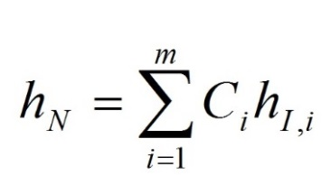

Figures
Figures should be with a resolution of minimum 300 dots per inch and followed by a figure caption.

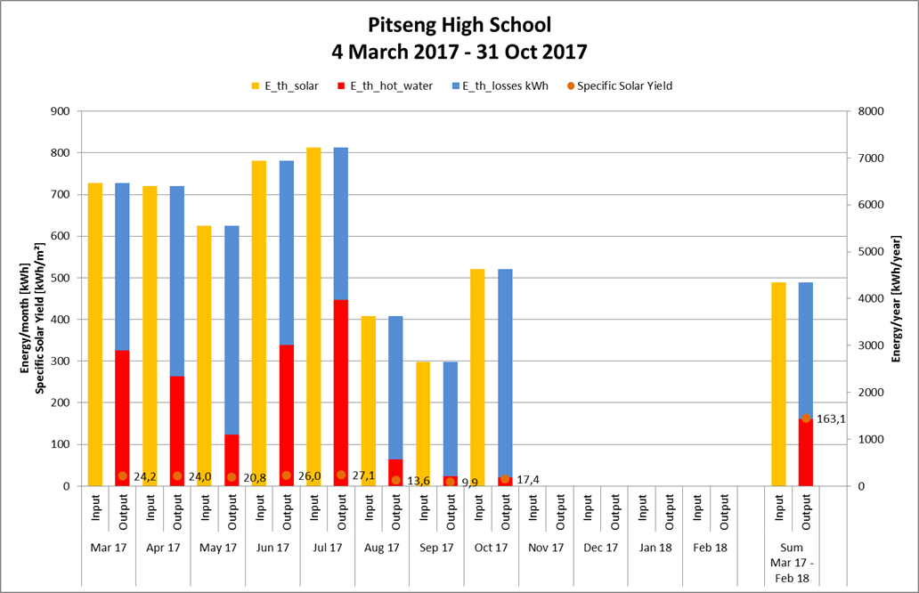
Fig. 1: Table captions (10 pt) should be justified as block and placed below the table

References
Green, C., (2018), Heating Systems for Houses, A Design Handbook. James & James (Sience Publishers) Ltd., London, UK.

Conclusion

Dear presenter please fill in for the chairs:

First name:
Surname:
Institute, company, organisation:
Key activities:
Miscellaneous:

